**Autumn 1 Homework Challenges**

Each challenge you complete will earn you 10 learning points. You have until Wednesday 23rd October 2024 to complete as many as you can!

|  |  |  |
| --- | --- | --- |
| Get creative and build a bug hotel to put in our outdoor area using recycled materials. | Create a representation of a toy in an artistic way of your choosing. This could be papier-mache, paint, collage, using natural resources. | Sketch a toy using pencils. |
| Complete the weekly Phonics reading and spelling videos on Seesaw. Bring in your spellings into class for me to see. | Write a story about a toy who gets lost. What happens to it? Include illustrations. | Find out about toys from the past and create a poster about them with facts and drawings. |

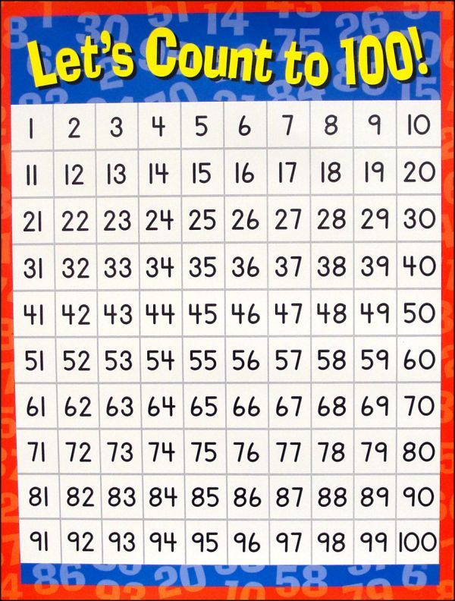

Count to 100!

Write and read all numbers between 0 and 100 by the end of October!